Meta Title: Custom mobile app development services | Reach out to us today!
Meta Description: If you need custom mobile app development services, we are ready to help you. We have a long track record of developing a diverse variety of apps.

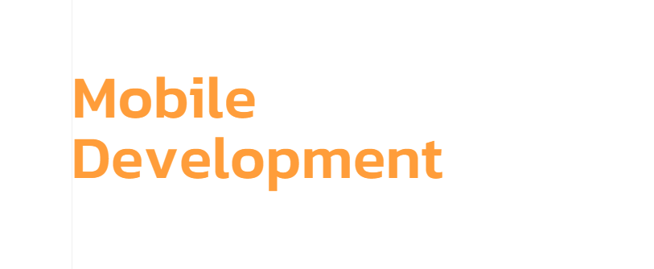

Custom Mobile App Development Services!
At The Neo Solutions, we provide the best custom mobile app development services to help you improve customer engagement and grow your business. You can rely on us for high-quality and bespoke mobile application development solutions. Reach out to us right away!
Call Today!

We are the experts of Custom Mobile App Development Services
Our custom mobile app development services are available for businesses of all sizes. We have developed mobile app solutions for businesses, funded startups, and enterprise organizations. Our mobile app developers can easily create native and cross-platform mobile applications on iOS and Android platforms. From helping you develop custom app ideas to existing projects, we do it all – on time and within budget. So, if you want a custom quote, reach out to us today.

Reasons to choose our Android & iOS mobile app development company
We have a long track record of helping businesses with custom mobile app development services. Our development team delivers high-end, intuitive apps that perfectly meet the client’s needs. You can count on us to plan, design, build, and release your app on your preferred time frame.
100+ Successful Projects | Development Expertise | On-Time Development
Innovative Development | Customized Development | Service Affordability

Get Comprehensive Custom Mobile App Development Services
The mobile app we develop for startups, enterprises, and brands impact millions of users and ensure unstoppable growth. Our custom mobile app development services include:
Android Mobile App Development | If you need an android mobile application development service, we can help you. Our experts can develop applications from scratch.
If you need an iOS mobile app, you can trust us to develop the best that runs smoothly on an iPhone, iPad, and Apple Watch. | iOS Mobile App Development
Cross-platform Mobile App Development | We can also help you develop cross-platform apps that work on android, Windows, web, and iOS platforms without any errors.

Our Mobile App Development is Streamlined!

We follow a step-by-step procedure

Step 1: Consultation
We discuss your goals, vision, target audience, and desired features in the mobile app

Step 2: Idea Validation
We assess the user needs & market trends to validate your app idea & finalize features

Step 3: Design & Development
Our experts do mobile app design and development with your feedback in loop

Step 4:QA and App Launch
We test the app to ensure its features are working smoothly for a smooth launch

Step 5: Post-Launch Support
We continue to provide you support even after the launch to maintain performance

Custom Mobile App Development Services we offer:
Enterprise App Development | Healthcare App Development | Educational App Development
No other enterprise mobile app development company can outmatch us. Our custom enterprise applications include frontend, backend, database, API integration, deployment, security, and support. | Our healthcare mobile app development company creates real-time and HIPAA-compliant apps. For these healthcare apps, we use technologies like AI/ML, IoT, Big Data Analytics, APIs, and Augmented Intelligence. | If your educational organization needs apps to innovate the learning experience, we can help you. Our developers are adept at creating apps with interactive lessons, progress tracking, and offline access.
Native App Development | Real Estate App Development | Weather App Development
We are experts in creating iOS applications that run on Apple devices. We do this using Swift, SwiftUI, Objective-C, and UIKit. If you need expert help with native app development, we are happy to help you. | We can create the best apps for property renters, real-estate developers, and property owners. With our real estate app development service, you can simplify the property searching and buying process. | We offer weather companies and meteorological agencies reliable weather app solutions with reliable data, personalized alerts, interactive maps, and tools that can help you keep your users informed.
Flutter App Development | Dating App Development | Location-Based App Development
Our experts can help you build a mobile application on both Android and iOS platforms – even if you have a limited budget and time constraints. We are the masters of creating cross-platforms applications using Flutter. | If you need a skilled developer for a dating app, we can easily develop dating apps for you that have features like video profiles, icebreakers, virtual dates, voice and audio messages, and background verification. | If you want to create an application with integration of Map APIs, GPS, Offline Capabilities, or Geolocation, let us help you. We are experts in developing location-based applications for all platforms.
Mobile App Integration | eCommerce App Development | Social Media App Development
We can help you integrate your mobile app with third-party services, databases, APIs, and tools like Firebase, AWS, and Zapier. We can easily streamline your app operations and enhance your customer experiences. | If you are looking for the best eCommerce mobile app development company, allow us to help you. We have experience in developing apps with payment gateway integration, inventory management, and advanced AI chat and search features. | We can help you develop social media apps with high-end features like intuitive interfaces, easy sharing, and real-time interactions. With our help, you can finally have a mobile app that lets you engage socially.

Industries we serve:
Retail | Manufacturing | Education
Healthcare | Entertainment | Hospitality
Tourism | Real Estate | Travel
Finance | Banking | It Industry

